TASK 4
The task 4 works for the first sample : u = 0x80000000 , x= 0xD80B1A63 and it find the correct key k* = k0.
However, it gives different value for each pair of the given test-set.
Result :
Test-set :
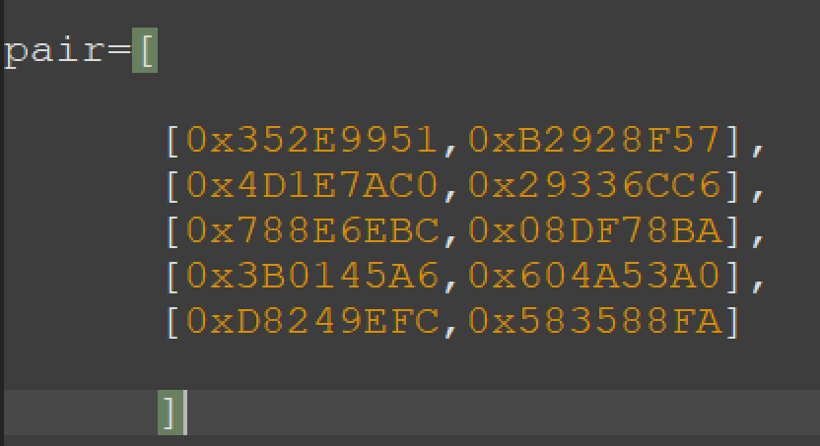
Guess key for each pair:
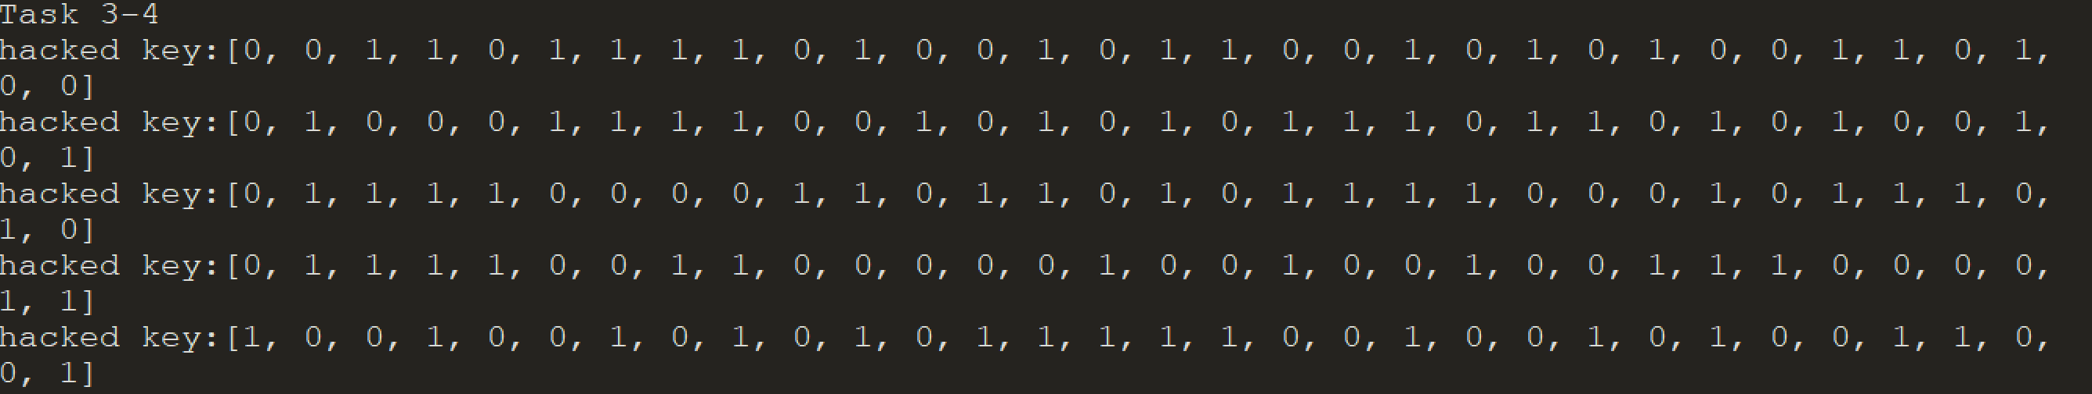

Alternative idea
Since the code seems correct and our group can’t figure out where is the problem, in base the result above, we can find a probabilistic guess key of the test set.
We consider each bit of every guessed key and we take the most likely values of them. For example for the bit 1, it’s probably “0”, cause it compares 4 times over 5.
Result :
[0 1 1 1 0 0 1 1 1 0 1 0 0 1 0 1 0 1 0 1 0 0 0 0 1 0 1 1 0 0 0 1 ] = 0x73A550B1

